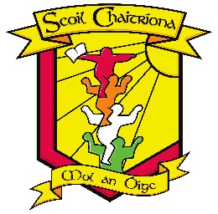
Scoil Chaitríona
College Street
Ballyshannon
___________________________________________________________________________________________ Co. Donegal
F94 RK10
Tel 071 98 51062
Principal: Ms Aoife Coen
Email:officescoilchaitriona@gmail.com

U.R. 17945G

Dear Parent(s),

Please see below our School Calendar for 2025-2026.

School Re-opens Thursday 28th August 2025
Friday 24th October 2025: Closed for Elections (Polling Station)
Monday 27th October 2025 - Friday 31st October 2025: Mid-Term Break
School Re-opens on Monday 3rd November 2025
Thursday 20th November 2025 – Parent Teacher Meetings
Monday 24th November 2025: School Closure
Friday 19th December 2025: School Finishes at 12pm for Christmas Closure
Monday 22nd December 2025 – Friday 2nd January 2026: Christmas Closure
School Re-opens on Monday 5th January 2026
Monday 2nd February 2026: School Closure for Public Holiday
Thursday 19th and Friday 20th February 2026: School Closed for Mid-Term Break
Tuesday 3rd March 2026: School Closed for Teacher Training Inservice Day
Monday 16th and Tuesday 17th March 2026: Public Holiday (St. Patrick’s Day) and School Closure
Friday 27th March 2026: School Finishes at 12pm for Easter Closure
Monday 30th March 2026 – Friday 10th April 2026: Easter Closure
School Re-opens Monday 13th April 2026
Monday 4th May 2026: School Closure for Public Holiday
Tuesday 26th May 2026: School Closed for Teacher Training Inservice Day
Friday 29th May and Monday 1st June 2026: School Closure and Public Holiday
Thursday 25th June 2026: Summer Holidays (School finishes at 12pm)

